**Employing Fast R-CNN to Obtain Cichlid Position Before and After Sand Manipulation Events During Bower-Building**

By Rhiya Sharma

Advisor: Patrick McGrath

Abstract

Pose estimation of the Lake Malawi cichlids while they are engaged in natural behaviors is an excellent way to study variations across species in long-term behaviors and how they are encoded in the genome and nervous system. Machine learning strategies are employed to automatically quantify their bower building, feeding and quivering behavior which might reveal some unforeseen patterns in their behaviors and help us understand the neural mechanisms underlying behaviors that are critical for survival and reproduction. I will be using the fast R-CNN model to accurately predict the position of the male and female cichlids before and after various sand manipulation decisions made during bower construction.

Background

Quantification of natural behavior of animals is important to understand how their brains work and also helps understand the causes behind behavioral evolution and its effects on the study of neural mechanisms underlying social behaviors [1]. Many species exhibit behaviors in which they manipulate the environment to build extended phenotype structures which are integral to survival and reproduction. Measuring these developing structures and the underlying behavioral decisions can provide quantitative descriptions of long-term goal-directed decisions-making in response to dynamic external stimuli [2, 3].

The construction behavior exhibited by the Lake Malawi cichlids is one such model of long-term goal-directed decision-making in which the males manipulate sand to construct large structures or bowers for courtship and mating. Large aquarium tanks, in the McGrath lab, containing a sand tray (approx. 14”x17”) are used to record the movements of the Malawi cichlids and allow the males to build bowers in the sand that serve as extended phonotypes and territories during courtship and spawning. Among the bower-building species two major behavioral phenotypes have repeatedly evolved – “castle-building” or construction of volcano-like elevations and “pit-digging” or excavation of crater-like depressions. These bower types are distributed widely across the species Mchenga conophorousm (MC), Copadichromis virginalis (CV) and Tramitichromis intermedius (TI).

While constructing the bowers, the males court the females in parallel and also get involved in aggressive encounters with conspecific males. The males repeatedly perform hundreds of scoops–spit bouts with their mouths per hour to build the bower. To dig pits, the males collect sand from the center of the pit and spit it elsewhere while to building castles, the males gather sand from elsewhere and spit it in a targeted location [4].

Tracking the species’ movements can pose a lot of challenges for experiments in the lab. The bowers are built in social environments in which multiple cichlids are allowed to freely interact with each other, the camouflage of the cichlids against the sand and finally the similarity in sand manipulation events for various behavioral categories like feeding and construction are some of the challenges faced which can make it difficult to identify the cichlids and selectively quantify bower construction behaviors from video data.

To battle these difficulties, the lab has employed a low-cost and automated system that automatically tracks both the developing bower and thousands of individual sand manipulation decisions made over weeklong periods across the MC, CV & TI species and hybrid crosses in the aquariums simultaneously.

Work done in Summer 2020

The convolution network Fast R-CNN [5], which is faster and more accurate than the traditional CNNs, is used to analyze the videoframes. It has been made to efficiently detect and classify cichlids based on their gender while they are engaged in building bowers. Over 5000 videoframes that I had previously annotated from 28 different trials - containing only male or female fishes from the bower building species and hybrid crosses along with some empty frames were fed into the fast R-CNN model to train it to distinguish between the males and female cichlids. The model was made to train over 100 epochs and its performance was measured through metrics like training loss, number of detections, IOU score distribution, classification accuracy, etc.

 

1. **(b)**

**Figure 1:** (a) Training loss per Epoch and (b) Average Number of Detections per Epoch

In Fig 1 (a), there are four types of losses that contribute to the training loss of the model – “loss_objectness” reflects the model’s ability to detect an object during the region proposed network (RPN) stage, “loss_classifier” reflects its ability to correctly classify an object during the RCNN stage, “box_reg” and “rpn_box_reg” refer to “bounding box regression losses” during the RCNN stage and the RPN stage respectively – reflects how well the model’s predicted box matches the true values. After training the model over 100 epochs the values for the corresponding losses are shown in Table 1.

**Table 1:** Losses Values

Gender Classification Analysis:

The prediction accuracy and the Intersection over Union scores (IOU) metrics were used to measure the accuracy of the position and gender classifications made by the model. IOU refers to the overlapping areas of intersection between two bounding boxes (manual annotations and the predicted annotations), divided by the total area of both bounding boxes. This produced an accuracy score that was used to measure how close two bounding boxes match.

In Figure 2 it can be seen that that out of 505 manual annotations the model could predict 445 annotations accurately (left). A distribution of the IOU scores for the female and male cichlids is also shown (right top and right bottom respectively). A brief summary of the gender analysis is shown below in Table 2. The average IOU score and the similar ratios of males to females for both manual annotations and predicted annotations shows that the model works well in classifying between the cichlids and tracking their movements.

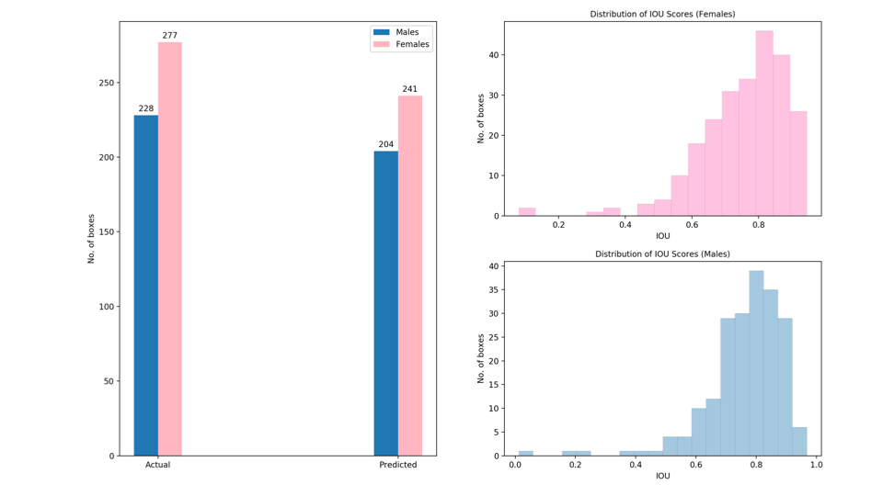

**Figure 2:** Box-wise analysis of the model’s performance in classifying between the male and female cichlids





**Table 2:** Gender Classification Summary Table (left) and Ratios Table (right)

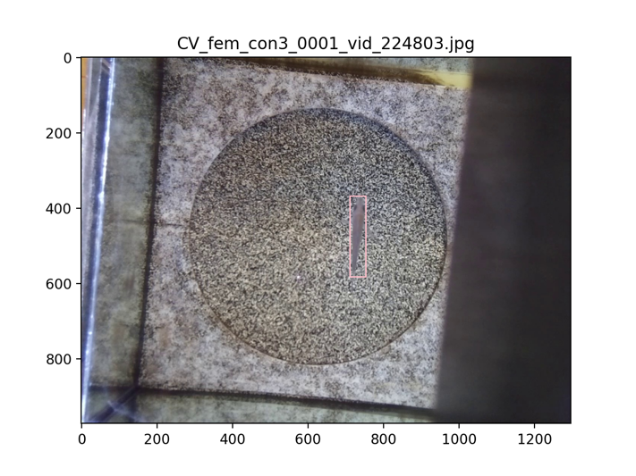 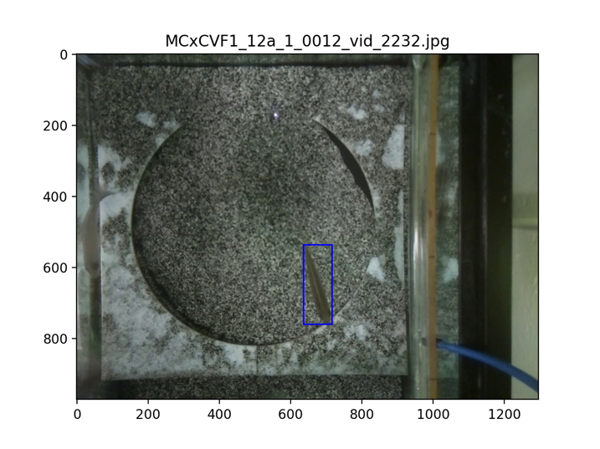

**Figure 3:** Accurate predictions made by the ML model across different cichlid species: Female CV cichlid (left) and male MCxCV cichlid detected (right).

Proposal for Fall 2020

A video analysis pipeline previously developed by the McGrath Lab to automatically identify sand manipulation events from raw video and classify each event into various behavioral categories. The pipeline was used to analyze seven full behavioral trials and more than 550,000 sand manipulation events were annotated [6].

From the work done during the summer, it can be seen that the fast R-CNN model can successfully classify between the male and female cichlids. Hence, for Fall 2020, I propose to work on making the model accurately predict the position of the male and female cichlids before and after all the sand manipulation events for all the behavioral categories which are based on bower construction, feeding and quivering behaviors. There are ten behavioral categories - bower scoop, bower spit, bower multiple event, feeding scoop, feeding spit, feeding multiple event, quivering, drop sand, other-fish, and other-no fish. My primary focus will be on seven behavioral trials comprising of the pit-digging species – 2 CV trials, 2 TI trials and the castle-building species – 3 MC trials.

I would like to thank the committee for taking the time to read my proposal, I hope to be funded for the Fall semester so that I can complete the proposed work.

References

[1] York, Ryan A., et al. "Evolution of bower building in Lake Malawi cichlid fish: phylogeny, morphology, and behavior." Frontiers in Ecology and Evolution 3 (2015): 18

[2] A. Russell, S. Morrison, E. Moschonas and D. Papaj, "Patterns of pollen and nectar foraging specialization by bumblebees over multiple timescales using RFID", Scientific Reports, vol. 7, no. 1, 2017. Available: 10.1038/srep42448

[3] R. Tucker, "The digging behavior and skin differentiations in Heterocephalus glaber", Journal of Morphology, vol. 168, no. 1, pp. 51-71, 1981. Available: 10.1002/jmor.1051680107

[4] York, R., Patil, C., Abdilleh, K., Johnson, Z., Conte, M., Genner, M., McGrath, P., Fraser, H., Fernald, R. and Streelman, J., 2018. Behavior-dependent cis regulation reveals genes and pathways associated with bower building in cichlid fishes. Proceedings of the National Academy of Sciences

[5] Girshick, R., 2020. Fast R-CNN

[6] Long, L., Johnson, Z. V., Li, J., Lancaster, T., Aljapur, V., Streelman, J. T., & McGrath, P. T., 2020. Automatic classification of cichlid behaviors using 3D Convolutional Residual Networks. *In revision*